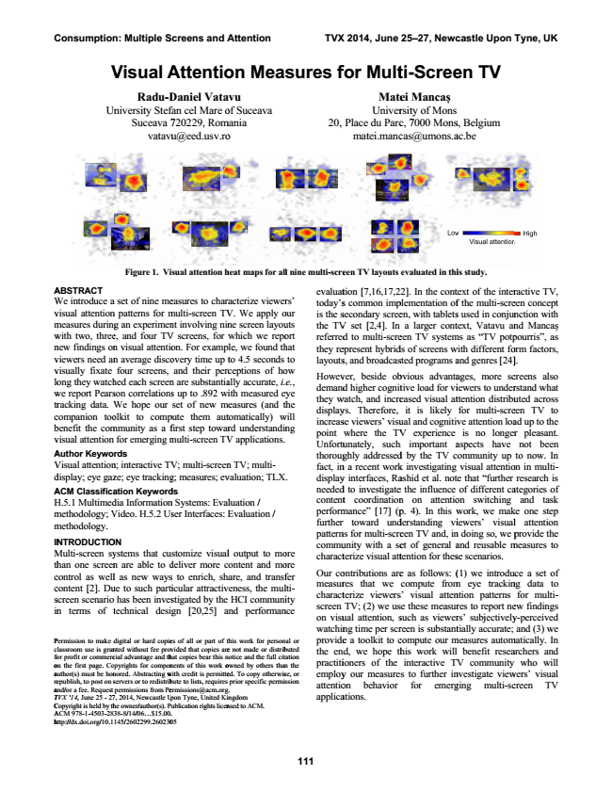

**Consumption: Multiple Screens and Attention TVX 2014, June 25–27, Newcastle Upon Tyne, UK**

**Visual V**

**A**

**Radu-D Un**

niversity Stef

Suceava 7 vatavu

**Figure 1. Vi**

A ABSTRACT W We introduce a a

set of nine me v visual attention

n patterns for m m measures during

g an experimen w with two, three

e, and four TV n new findings on

n visual attentio v viewers need an

n average disco v visually fixate

four screens, lo

ong they watch

hed each screen w we report Pears

son correlations tr

racking data. We W

hope our c companion too

olkit to comp b benefit the com

mmunity as a f v visual attention

for emerging m A Author Keywo

rds V Visual attention

n; interactive TV d display; eye gaz

ze; eye tracking A ACM Classifica

ation Keyword H H.5.1 Multimed

dia Information m methodology; Video. V

H.5.2 Us m methodology.

**IN**

**NTRODUCTIO**

ON M Multi-screen sy

ystems that cu th

han one screen

n are able to d c control as well

l as new ways c content [2]. Du

ue to such parti s screen scenario

has been inves in

n terms of technical t

desi

P Permission to make d c

lassroom use is gran fo

or profit or commerc o on the first page. Co a author(s) must be hon re

epublish, to post on s a and/or a fee. Request T TVX ‘14, June 25 - 27 C Copyright is held by th A ACM 978-1-4503-283 h http://dx.doi.org/10.1

**111**

**Attentio**

Daniel Vata fan cel Mare o 720229, Rom u@eed.usv.ro

**isual attention h**

easures to chara multi-screen TV nt involving nin V screens, for w on. For exampl overy time up t and their perc n are substantia s up to .892 wi set of new me pute them aut

first step towar multi-screen TV

V; multi-screen g; measures; ev ds n Systems: Eval

ser Interfaces: E

stomize visual deliver more c s to enrich, sha icular attractiv stigated by the gn [20,25] an

digital or hard copie nted without fee prov cial advantage and th pyrights for compon nored. Abstracting w servers or to redistrib permissions from Pe 7, 2014, Newcastle Up he owner/author(s). Pu 38-8/14/06...$15.00. 145/2602299.260230

**on Meas**

vu of Suceava mania

o

**heat maps for all**

acterize viewer V. We apply o ne screen layou which we repo le, we found th to 4.5 seconds ceptions of ho ally accurate, i. ith measured ey easures (and th tomatically) w rd understandin V applications.

n TV; multi- valuation; TLX

luation / Evaluation /

l output to mo ontent and mo are, and transf eness, the mul HCI communi nd performan

es of all or part of th vided that copies are hat copies bear this n nents of this work o with credit is permitte bute to lists, requires ermissions@acm.org

pon Tyne, United Kin ublication rights licen . 05

**sures f**

20,

**l nine multi-scre**

rs’ our uts ort hat to ow e., ye he will ng

.

ore ore fer lti- ity nce

evaluat today’s is the s the TV referred they re layouts Howev demand they w display increas point Unfortu thoroug fact, in display needed content perform further pattern commu charact Our co measur charact screen on visu watchin his work for person

provide e not made or distrib otice and the full cita owned by others than ed. To copy otherwis prior specific permis . ngdom

the en practiti employ attentio applica nsed to ACM.

al or buted ation n the se, or ssion

**for Mult**

Mate Univer Place du Parc matei.manc

**een TV layouts**

tion [7,16,17,2 s common imp secondary scree V set [2,4]. In

d to multi-scre epresent hybrid s, and broadcas ver, beside ob d higher cognit watch, and incre ys. Therefore, se viewers’ visu

where the TV tunately, such ghly addressed n a recent work y interfaces, Ra d to investigate

t coordination mance” [17] (p r toward und ns for multi-scre unity with a se terize visual att ontributions are res that we terize viewers TV; (2) we us ual attention, s ng time per scr e a toolkit to c nd, we hope th ioners of the y our measure on behavior ations.

**ti-Scree**

ei Mancaș rsity of Mons c, 7000 Mons cas@umons.a

**evaluated in thi**

22]. In the cont plementation of en, with tablets a larger cont een TV system ds of screens w sted programs a bvious advanta tive load for vi eased visual at it is likely ual and cognitiv V experience h important a d by the TV c k investigating ashid et al. not e the influence

n on attentio p. 4). In this w derstanding vi een TV and, in et of general a tention for thes e as follows: ( compute from s’ visual atten se these measur such as viewer reen is substant compute our m his work will

interactive TV es to further in for emerg

**en TV**

s, Belgium ac.be

**is study.**

text of the inter f the multi-scre s used in conjun text, Vatavu an ms as “TV potp with different fo and genres [24] ages, more sc iewers to under ttention distribu for multi-scre ve attention loa is no longer aspects have ommunity up

visual attentio e that “further

of different ca on switching work, we mak iewers’ visual n doing so, we p and reusable m se scenarios. (1) we introdu m eye trackin ntion patterns

res to report ne rs’ subjectively tially accurate; measures autom benefit resea V community nvestigate view ging multi-sc

ractive TV, een concept nction with nd Mancaș pourris”, as orm factors,

]. creens also rstand what uted across een TV to ad up to the r pleasant. not been to now. In on in multi- research is ategories of and task ke one step l attention provide the measures to

uce a set of ng data to for multi- ew findings y-perceived and (3) we matically. In archers and who will wers’ visual creen TV

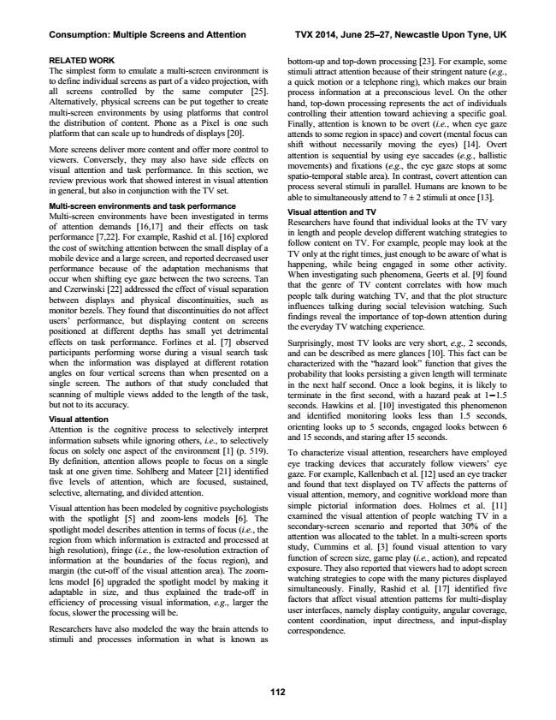

**Consumption: Multiple Screens and Attention TVX 2014, June 25–27, Newcastle Upon Tyne, UK**

**112 RELATED WORK**

bottom-up and top-down processing [23]. For example, some The simplest form to emulate a multi-screen environment is

stimuli attract attention because of their stringent nature (e.g., to define individual screens as part of a video projection, with

a quick motion or a telephone ring), which makes our brain all screens controlled by the same computer [25].

process information at a preconscious level. On the other Alternatively, physical screens can be put together to create

hand, top-down processing represents the act of individuals multi-screen environments by using platforms that control

controlling their attention toward achieving a specific goal. the distribution of content. Phone as a Pixel is one such

Finally, attention is known to be overt (i.e., when eye gaze platform that can scale up to hundreds of displays [20].

attends to some region in space) and covert (mental focus can More screens deliver more content and offer more control to viewers. Conversely, they may also have side effects on visual attention and task performance. In this section, we review previous work that showed interest in visual attention in general, but also in conjunction with the TV set.

shift without necessarily moving the eyes) [14]. Overt attention is sequential by using eye saccades (e.g., ballistic movements) and fixations (e.g., the eye gaze stops at some spatio-temporal stable area). In contrast, covert attention can process several stimuli in parallel. Humans are known to be able to simultaneously attend to 7 ± 2 stimuli at once [13]. Multi-screen environments and task performance Multi-screen environments have been investigated in terms of attention demands [16,17] and their effects on task performance [7,22]. For example, Rashid et al. [16] explored the cost of switching attention between the small display of a mobile device and a large screen, and reported decreased user performance because of the adaptation mechanisms that occur when shifting eye gaze between the two screens. Tan and Czerwinski [22] addressed the effect of visual separation between displays and physical discontinuities, such as monitor bezels. They found that discontinuities do not affect users’ performance, but displaying content on screens positioned at different depths has small yet detrimental

Visual attention and TV Researchers have found that individual looks at the TV vary in length and people develop different watching strategies to follow content on TV. For example, people may look at the TV only at the right times, just enough to be aware of what is happening, while being engaged in some other activity. When investigating such phenomena, Geerts et al. [9] found that the genre of TV content correlates with how much people talk during watching TV, and that the plot structure influences talking during social television watching. Such findings reveal the importance of top-down attention during the everyday TV watching experience. effects on task performance. Forlines et al. [7] observed

Surprisingly, most TV looks are very short, e.g., 2 seconds, participants performing worse during a visual search task

and can be described as mere glances [10]. This fact can be when the information was displayed at different rotation

characterized with the “hazard look” function that gives the angles on four vertical screens than when presented on a

probability that looks persisting a given length will terminate single screen. The authors of that study concluded that

in the next half second. Once a look begins, it is likely to scanning of multiple views added to the length of the task,

terminate in the first second, with a hazard peak at 1−1.5 but not to its accuracy.

seconds. Hawkins et al. [10] investigated this phenomenon

Visual attention Attention is the cognitive process to selectively interpret information subsets while ignoring others, i.e., to selectively

and identified monitoring looks less than 1.5 seconds, orienting looks up to 5 seconds, engaged looks between 6 and 15 seconds, and staring after 15 seconds. focus on solely one aspect of the environment [1] (p. 519). By definition, attention allows people to focus on a single task at one given time. Sohlberg and Mateer [21] identified five levels of attention, which are focused, sustained, selective, alternating, and divided attention.

To characterize visual attention, researchers have employed eye tracking devices that accurately follow viewers’ eye gaze. For example, Kallenbach et al. [12] used an eye tracker and found that text displayed on TV affects the patterns of visual attention, memory, and cognitive workload more than Visual attention has been modeled by cognitive psychologists with the spotlight [5] and zoom-lens models [6]. The spotlight model describes attention in terms of focus (i.e., the region from which information is extracted and processed at high resolution), fringe (i.e., the low-resolution extraction of information at the boundaries of the focus region), and margin (the cut-off of the visual attention area). The zoom- lens model [6] upgraded the spotlight model by making it adaptable in size, and thus explained the trade-off in efficiency of processing visual information, e.g., larger the focus, slower the processing will be.

Researchers have also modeled the way the brain attends to stimuli and processes information in what is known as

simple pictorial information does. Holmes et al. [11] examined the visual attention of people watching TV in a secondary-screen scenario and reported that 30% of the attention was allocated to the tablet. In a multi-screen sports study, Cummins et al. [3] found visual attention to vary function of screen size, game play (i.e., action), and repeated exposure. They also reported that viewers had to adopt screen watching strategies to cope with the many pictures displayed simultaneously. Finally, Rashid et al. [17] identified five factors that affect visual attention patterns for multi-display user interfaces, namely display contiguity, angular coverage, content coordination, input directness, and input-display correspondence.

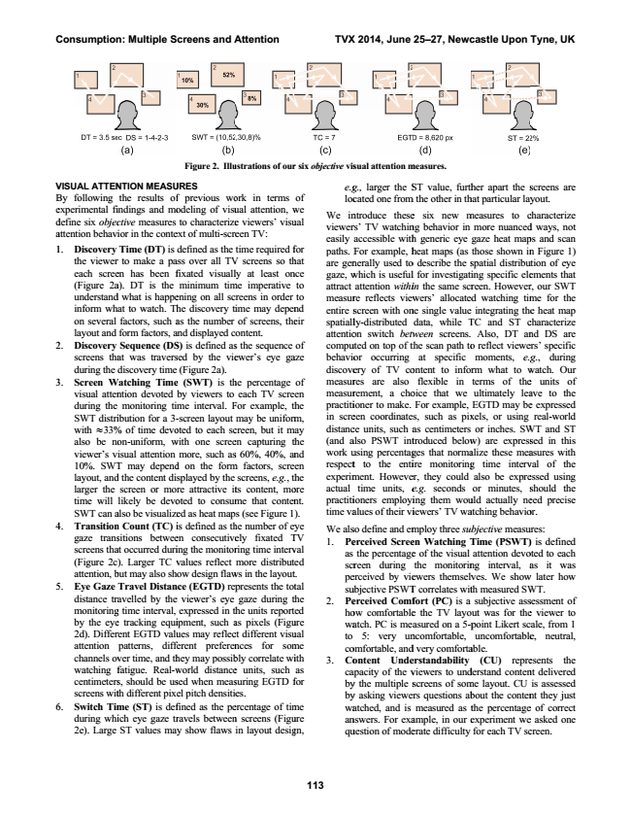

**Consumption: Multiple Screens and Attention TVX 2014, June 25–27, Newcastle Upon Tyne, UK**

V VISUAL ATTEN B By following e experimental fi d define six objec a attention behavi 1 1. Discovery the viewer each scree (Figure 2a understand inform wh on several layout and 2 2. Discovery

screens tha during the 3 3. Screen W

visual atten during the SWT distri with 33% also be no viewer’s v 10%. SWT layout, and larger the time will SWT can a 4 4. Transition gaze trans screens tha (Figure 2c attention, b 5 5. Eye Gaze

distance tra monitoring by the eye 2d). Differ attention channels ov watching f centimeters screens wit 6 6. Switch Tim

during whi 2e). Large

**113**

NTION MEASU the results of indings and mo ctive measures ior in the conte Time (DT) is r to make a pa en has been f a). DT is the d what is happe

at to watch. Th factors, such a form factors, a Sequence (DS at was travers discovery time Watching Time ntion devoted

monitoring ti ibution for a 3- % of time devo on-uniform, w isual attention T may depend d the content di screen or mo likely be devo also be visualize n Count (TC) i sitions betwee at occurred duri

). Larger TC v but may also sh Travel Distan avelled by the g time interval, e tracking equi rent EGTD valu patterns, diff ver time, and th fatigue. Real-w s, should be us th different pix me (ST) is def ich eye gaze tr ST values ma

**Figure 2. Illu**

**URES**

f previous wo odeling of visu to characterize ext of multi-scre defined as the ass over all TV fixated visuall minimum tim ening on all scr he discovery ti as the number and displayed c S) is defined as sed by the vie

(Figure 2a). e (SWT) is th by viewers to me interval. F -screen layout oted to each sc with one scree more, such as d on the form splayed by the re attractive it oted to consum ed as heat map is defined as th en consecutive ing the monitor values reflect how design flaw nce (EGTD) rep e viewer’s eye

expressed in th ipment, such a ues may reflec ferent preferen hey may possib world distance sed when meas el pitch densitie fined as the pe ravels between y show flaws

**ustrations of our**

ork in terms ual attention, w e viewers’ visu een TV: time required f V screens so th ly at least on me imperative reens in order ime may depen of screens, the ontent. s the sequence ewer’s eye ga

he percentage

each TV scre For example, th

may be uniform creen, but it m en capturing th s 60%, 40%, an m factors, scre

screens, e.g., th ts content, mo me that conten s (see Figure 1 he number of ey ely fixated T ring time interv more distribut ws in the layout presents the tot gaze during t he units report as pixels (Figu ct different visu

nces for som bly correlate wi e units, such suring EGTD f es. ercentage of tim n screens (Figu in layout desig

***r six objective vis***

of we ual

for hat nce to to nd eir

of aze

of en he m, ay he nd en he ore nt. ). ye TV val ed t. tal the ed ure ual me ith as for

me ure gn,

e.g loc We in viewer easily paths. F are gen gaze, w attract measur entire s spatiall attentio compu behavio discove measur measur practiti in scre distanc (and a work u respect experim actual practiti time va

We als 1. Pe

as scr pe su 2. Pe ho wa to co 3. Co

ca by by wa an qu

**sual attention m**

g., larger the S cated one from ntroduce these rs’ TV watchin accessible with For example, h nerally used to which is useful attention withi re reflects view screen with on ly-distributed on switch betw uted on top of t or occurring ery of TV co res are also rement, a cho ioner to make. een coordinate ce units, such a also PSWT int using percentag t to the enti ment. Howeve

time units, e ioners employi alues of their vi

so define and em erceived Scree the percentage reen during erceived by vie ubjective PSWT erceived Comf ow comfortable atch. PC is me

5: very un omfortable, and ontent Unde apacity of the v y the multiple s y asking viewe atched, and is nswers. For exa uestion of mode

**measures.**

ST value, furth m the other in th

e six new m ng behavior in h generic eye heat maps (as o describe the s l for investigati in the same scr wers’ allocated ne single value

data, while T tween screens. the scan path to at specific ontent to infor flexible in oice that we For example, es, such as pix as centimeters troduced below ges that norma ire monitoring er, they could e.g. seconds ing them wou iewers’ TV wa

mploy three sub en Watching T e of the visual

the monitorin ewers themselv T correlates wit fort (PC) is a e the TV layo asured on a 5-p ncomfortable, d very comforta erstandability viewers to und screens of som ers questions ab measured as t ample, in our e erate difficulty

her apart the s hat particular lay measures to c more nuanced gaze heat map those shown in spatial distribu ing specific ele reen. However d watching tim integrating the TC and ST c Also, DT an o reflect viewe

moments, e.g rm what to w terms of the ultimately lea EGTD may be xels, or using

or inches. SW w) are express alize these mea g time interv also be expre or minutes, s uld actually ne atching behavio

bjective measu Time (PSWT) attention devo ng interval, a ves. We show th measured SW subjective ass ut was for the point Likert sc

uncomfortable able.

(CU) repre derstand conten me layout. CU

bout the conten the percentage experiment we for each TV sc

screens are yout. characterize d ways, not ps and scan n Figure 1) ution of eye ements that r, our SWT me for the e heat map characterize nd DS are ers’ specific g., during watch. Our e units of ave to the e expressed real-world WT and ST sed in this asures with val of the essed using should the eed precise or.

ures:

) is defined oted to each as it was w later how

WT. sessment of e viewer to cale, from 1 e, neutral,

esents the nt delivered is assessed nt they just e of correct e asked one creen.

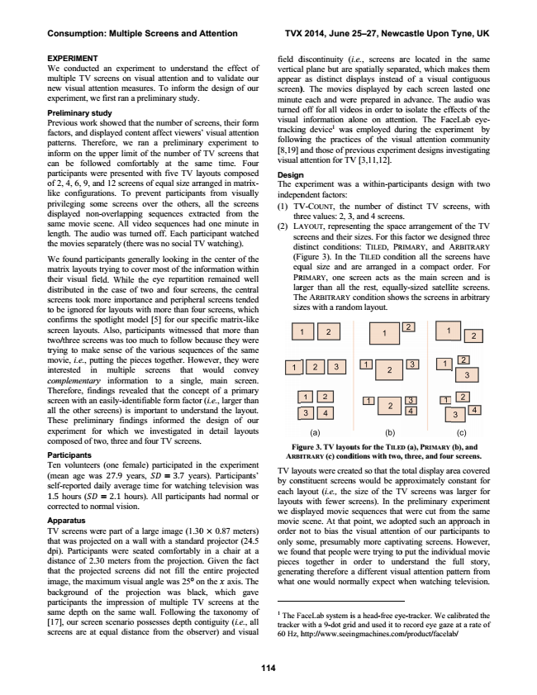

**Consumption: Multiple Screens and Attention TVX 2014, June 25–27, Newcastle Upon Tyne, UK**

**114 E EXPERIMENT**

field d W We conducted

vertica m multiple TV sc

appear n new visual atte

screen) e experiment, we

minute

P Preliminary stu P Previous work f factors, and disp p patterns. There in

nform on the u c can be follow

turned visual trackin followi [8,19] a visual a p participants we

Design o of 2, 4, 6, 9, an

The ex li

ike configurat

indepen p privileging som d displayed non- s same movie sc le

ength. The aud th

he movies sepa

(1) TV

thr (2) L

A scr dis W We found parti m matrix layouts t th

heir visual fie d distributed in th s screens took m to

o be ignored fo

(F eq PR lar Th siz c confirms the sp s screen layouts. tw

wo/three screen tr

rying to make m movie, i.e., put in

nterested in c complementary T Therefore, find s screen with an e a all the other sc T These prelimin e experiment for c composed of tw

**Fig P Participants**

**A**

RBI T Ten volunteers ( (mean age was s self-reported da 1 1.5 hours ( c corrected to nor

TV lay by con each la layouts we disp A Apparatus

movie T TV screens wer

order n th

hat was projec

only so d dpi). Participan

we fou d distance of 2.3

pieces th

hat the projec

generat im

mage, the max

what o b background of p participants the s same depth on [

17], our screen s screens are at e

an experimen

nt to understan

nd the effect

of creens on visua

al attention and

d to validate o

our ention measure

s. To inform th

he design of o

our first ran a prel

iminary study.

udy showed that th

e number of sc

creens, their for

rm played content

affect viewers

s’ visual attentio

on efore, we ran

a preliminary

y experiment

to upper limit of

the number of

f TV screens th

hat wed comfortab

bly at the sa

ame time. Fo

our ere presented w

with five TV la

ayouts compos

ed nd 12 screens o

f equal size arr

ranged in matri

ix- ions. To prev

vent participant

ts from visual

lly me screens ov

ver the others,

all the scree

ens -overlapping s

sequences extr

racted from th

he cene. All video

o sequences ha

ad one minute

in dio was turned

d off. Each par

rticipant watch

ed arately (there was w

no social TV

V watching).

icipants genera

ally looking in

the center of th

he trying to cover

most of the in

nformation with

hin ld. While the

eye repartition

n remained we

ell he case of two

o and four scr

reens, the centr

ral ore importance

e and periphera

al screens tend

ed or layouts with

h more than fou

ur screens, whi

ch potlight model

[5] for our spe

ecific matrix-lik

ke Also, particip

pants witnessed

d that more th

an ns was too mu

ch to follow be

ecause they we

ere sense of the v

various sequen

nces of the sam

me tting the pieces

s together. How

wever, they we

ere multiple sc

creens that

would conv

ey y information

to a single

e, main scree

en. dings revealed

that the conce

ept of a prima

ary easily-identifia

able form factor

r (i.e., larger th

an creens) is impo

ortant to under

stand the layou

ut. nary findings

informed the

design of o

our r which we investigated i

in

n detail layou

uts wo, three and fo

our TV screens. .

(one female)

participated in

n the experime

ent s 27.9 years,

= 3.7 year

rs). Participant

ts’ aily average tim

me for watchin

ng television was

w = 2.1 hours).

All participant

ts had normal

or rmal vision.

re part of a lar

rge image (1.30

0 0.87 meter

rs) cted on a wall w

with a standard

d projector (24

4.5 nts were seated

d comfortably

in a chair at

t a 0 meters from

m the projection

n. Given the fa

act ted screens di

id not fill the

entire project

ed ximum visual an

ngle was 250 on

n the axis. Th

he f the projecti

ion was blac

ck, which gav

ve e impression of o

multiple TV

V screens at th

he the same wal

ll. Following t

the taxonomy

of n scenario poss

sesses depth co

ontiguity (i.e., all

a equal distance

from the obse

erver) and visu

ual

1 The F tracker 60 Hz, h

discontinuity ( al plane but are r as distinct di ). The movies e each and wer off for all vide information a ng device1 was ing the practic and those of pr attention for TV

n xperiment was ndent factors: V-C

OUNT

, the ree values: 2, 3 AYOUT

, represe reens and their stinct conditio Figure 3). In th qual size and RIMARY, one s rger than all t he A

RBITRARY zes with a rand

**gure 3. TV layou ITRARY**

**(c) cond**

youts were crea nstituent screen ayout (i.e., the s with fewer s played movie scene. At that not to bias the ome, presumab und that people

together in ting therefore one would norm

FaceLab system i with a 9-dot gri http://www.seei

(i.e., screens a e spatially sepa isplays instead s displayed by re prepared in eos in order to alone on atten s employed du ces of the vis revious experim V [3,11,12].

s a within-parti

number of d 3, and 4 screens enting the spac r sizes. For this ons: TILED, PR he TILED condi are arranged i screen acts as the rest, equall

condition show dom layout.

**uts for the T**

**ILED ditions with two,**

ated so that the ns would be ap e size of the T screens). In the sequences that point, we ado e visual attenti bly more captiv e were trying to

order to und a different visu mally expect w

is a head-free ey id and used it to ingmachines.com

are located in arated, which m d of a visual y each screen

advance. The o isolate the eff ntion. The Fac uring the exper sual attention c ment designs in

icipants design

distinct TV scr

s. ce arrangement s factor we des RIMARY, and A ition all the sc in a compact

the main scr ly-sized satelli ws the screens

**D**

**(a), P**

**RIMARY , three, and four**

total display ar pproximately c V screens was e preliminary t were cut from opted such an a ion of our part vating screens o put the individ

derstand the ual attention pa when watching

ye-tracker. We ca record eye gaze m/product/facela

n the same makes them contiguous lasted one audio was ffects of the ceLab eye- riment by community nvestigating

n with two

reens, with

t of the TV igned three ARBITRARY creens have order. For een and is ite screens. in arbitrary

**(b), and r screens.**

rea covered constant for s larger for experiment m the same approach in ticipants to . However, dual movie full story, attern from television.

alibrated the e at a rate of ab/

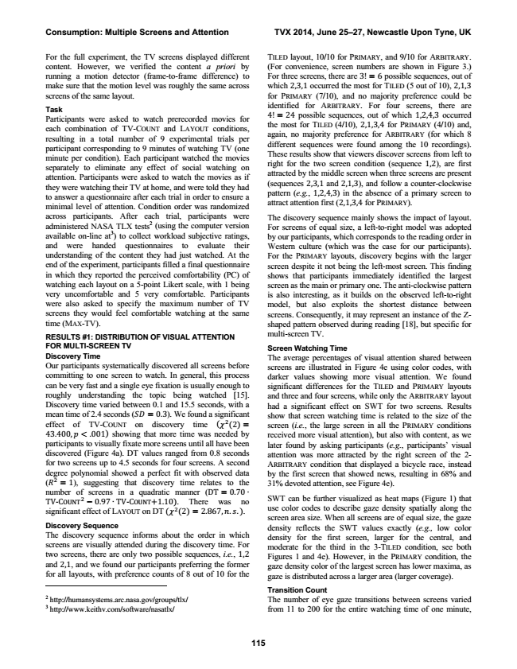

**Consumption: Multiple Screens and Attention TVX 2014, June 25–27, Newcastle Upon Tyne, UK**

For the full experiment, the TV screens displayed different

TILED layout, 10/10 for PRIMARY, and 9/10 for ARBITRARY. content. However, we verified the content a priori by

(For convenience, screen numbers are shown in Figure 3.) running a motion detector (frame-to-frame difference) to

For three screens, there are 3! = 6 possible sequences, out of make sure that the motion level was roughly the same across

which 2,3,1 occurred the most for T

ILED screens of the same layout.

Task Participants were asked to watch prerecorded movies for each combination of TV-C

OUNT

**115**

(5 out of 10), 2,1,3 for P

RIMARY

(7/10), and no majority preference could be identified for A

RBITRARY

. For four screens, there are 4! = 24 possible sequences, out of which 1,2,4,3 occurred and L

AYOUT

conditions, resulting in a total number of 9 experimental trials per participant corresponding to 9 minutes of watching TV (one minute per condition). Each participant watched the movies separately to eliminate any effect of social watching on attention. Participants were asked to watch the movies as if they were watching their TV at home, and were told they had to answer a questionnaire after each trial in order to ensure a minimal level of attention. Condition order was randomized

the most for T

ILED

(4/10), 2,1,3,4 for P

RIMARY

(4/10) and, again, no majority preference for ARBITRARY (for which 8 different sequences were found among the 10 recordings). These results show that viewers discover screens from left to right for the two screen condition (sequence 1,2), are first attracted by the middle screen when three screens are present (sequences 2,3,1 and 2,1,3), and follow a counter-clockwise pattern (e.g., 1,2,4,3) in the absence of a primary screen to attract attention first (2,1,3,4 for P

RIMARY across participants. After each trial, participants were administered NASA TLX tests2 (using the computer version available on-line at3) to collect workload subjective ratings, and were handed questionnaires to evaluate their understanding of the content they had just watched. At the end of the experiment, participants filled a final questionnaire in which they reported the perceived comfortability (PC) of watching each layout on a 5-point Likert scale, with 1 being very uncomfortable and 5 very comfortable. Participants were also asked to specify the maximum number of TV screens they would feel comfortable watching at the same time (MAX-TV).

RESULTS #1: DISTRIBUTION OF VISUAL ATTENTION FOR MULTI-SCREEN TV Discovery Time Our participants systematically discovered all screens before committing to one screen to watch. In general, this process can be very fast and a single eye fixation is usually enough to roughly understanding the topic being watched [15]. Discovery time varied between 0.1 and 15.5 seconds, with a mean time of 2.4 seconds ( = 0.3). We found a significant effect of TV-COUNT on discovery time ( (2) = 43.400, < .001) showing that more time was needed by participants to visually fixate more screens until all have been discovered (Figure 4a). DT values ranged from 0.8 seconds for two screens up to 4.5 seconds for four screens. A second degree polynomial showed a perfect fit with observed data ( = 1), suggesting that discovery time relates to the number of screens in a quadratic manner (DT = 0.70 ∙ TV-C

OUNT

).

The discovery sequence mainly shows the impact of layout. For screens of equal size, a left-to-right model was adopted by our participants, which corresponds to the reading order in Western culture (which was the case for our participants). For the PRIMARY layouts, discovery begins with the larger screen despite it not being the left-most screen. This finding shows that participants immediately identified the largest screen as the main or primary one. The anti-clockwise pattern is also interesting, as it builds on the observed left-to-right model, but also exploits the shortest distance between screens. Consequently, it may represent an instance of the Z- shaped pattern observed during reading [18], but specific for multi-screen TV.

Screen Watching Time The average percentages of visual attention shared between screens are illustrated in Figure 4e using color codes, with darker values showing more visual attention. We found significant differences for the T

ILED

layouts and three and four screens, while only the ARBITRARY layout had a significant effect on SWT for two screens. Results show that screen watching time is related to the size of the screen (i.e., the large screen in all the PRIMARY conditions received more visual attention), but also with content, as we later found by asking participants (e.g., participants’ visual attention was more attracted by the right screen of the 2- A

RBITRARY

and P

RIMARY

condition that displayed a bicycle race, instead by the first screen that showed news, resulting in 68% and 31% devoted attention, see Figure 4e).

− 0.97 ∙ TV-C

OUNT

+1.10). There was no significant effect of LAYOUT on DT ( (2) = 2.867, . .).

SWT can be further visualized as heat maps (Figure 1) that use color codes to describe gaze density spatially along the screen area size. When all screens are of equal size, the gaze Discovery Sequence The discovery sequence informs about the order in which screens are visually attended during the discovery time. For two screens, there are only two possible sequences, i.e., 1,2 and 2,1, and we found our participants preferring the former for all layouts, with preference counts of 8 out of 10 for the

density reflects the SWT values exactly (e.g., low color density for the first screen, larger for the central, and moderate for the third in the 3-TILED condition, see both Figures 1 and 4e). However, in the PRIMARY condition, the gaze density color of the largest screen has lower maxima, as gaze is distributed across a larger area (larger coverage).

Transition Count 2 http://humansystems.arc.nasa.gov/groups/tlx/

The number of eye gaze transitions between screens varied 3 http://www.keithv.com/software/nasatlx/

from 11 to 200 for the entire watching time of one minute,

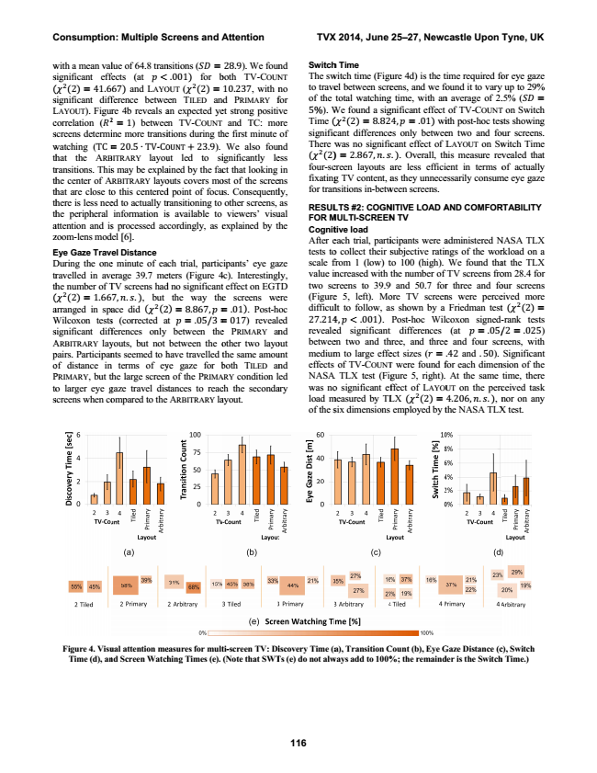

**Consumption: Multiple Screens and Attention TVX 2014, June 25–27, Newcastle Upon Tyne, UK**

w with a mean val s significant eff ( ( (2) = 41.6 s significant diff L LAYOUT). Figur c correlation ( s screens determi w watching (TC = th

hat the A

RB tr

ransitions. This th

he center of A th

hat are close to th

here is less nee th

he peripheral a attention and is z zoom-lens mod

E Eye Gaze Trav D During the one tr

ravelled in ave th

he number of T ( ( (2) = 1.66 a arranged in spa W Wilcoxon tests s significant diff A A

RBITRARY

lay p pairs. Participan o of distance in P P

RIMARY

, but t to

o larger eye g s screens when co

**Figure 4. Visu Time (d), an**

**116**

lue of 64.8 tran fects (at <

67) and LAYO ference betwe re 4b reveals a = 1) betwee ine more transi = 20.5 ∙ TV-C

O BITRARY

layou s may be expla A

RBITRARY

layo o this centered ed to actually tr information is s processed ac del [6].

el Distance e minute of ea erage 39.7 me TV screens had 7, . .), but ace did ( (2 s (corrected a fferences only youts, but not nts seemed to h n terms of ey the large screen gaze travel dis ompared to the

**ual attention me nd Screen Watch**

nsitions ( =

.001) for b OUT ( (2) = een TILED and an expected ye en TV-COUNT itions during th OUNT

+ 23.9). ut led to si ained by the fac outs covers mo d point of focu ransitioning to s available to cordingly, as e

ach trial, partic eters (Figure 4 d no significant

the way the 2) = 8.867, = at = .05/3 =

between the between the o have travelled t ye gaze for b n of the P

RIMA stances to reac ARBITRARY la

**easures for mult hing Times (e).**

28.9). We foun both TV-COUN 10.237, with n d PRIMARY f et strong positiv

and TC: mo he first minute

We also foun ignificantly le ct that looking ost of the scree us. Consequentl other screens,

viewers’ visu explained by th

ipants’ eye ga 4c). Interestingl t effect on EGT e screens we = .01). Post-h = 017) reveal e PRIMARY an other two layo the same amou both T

ILED

an ARY

condition l ch the seconda ayout.

**ti-screen TV: Di (Note that SWT**

**Switch nd NT**

The sw no for

to trave of the ve ore

5%). W Time ( of nd ess in ens ly,

signific There w ( (2) four-sc fixating for tran as ual he

RESUL FOR M Cognit After e tests to aze

scale f ly,

value in TD

two sc ere

(Figure oc

difficul ed

27.214 nd

reveale out

betwee unt

medium nd

effects ed

NASA ary

was no load m of the s

**iscovery Time (a Ts (e) do not alw**

h Time witch time (Figu el between scre total watching We found a sig ( (2) = 8.82 cant difference was no signific ) = 2.867, . creen layouts a g TV content, a nsitions in-betw

**LTS #2: COGN MULTI-SCREEN**

tive load each trial, parti o collect their s from 1 (low) t increased with creens to 39.9 e 5, left). Mo lt to follow, a 4, < .001). ed significant en two and th m to large effe

of TV-C

OUNT A TLX test (Fig o significant ef measured by TL six dimensions

**a), Transition C ways add to 100%**

ure 4d) is the t eens, and we fo g time, with an gnificant effect

4, = .01) wi es only betwee

cant effect of L .). Overall, th are less effici as they unnece ween screens.

**NITIVE LOAD A**

**N TV**

icipants were a subjective ratin to 100 (high). the number of 9 and 50.7 for ore TV screen as shown by a Post-hoc Wil t differences hree, and three ect sizes ( = T

were found f gure 5, right). ffect of L

AYOU LX ( (2) =

employed by t

**Count (b), Eye G %; the remaind**

time required fo found it to vary n average of 2. of TV-COUNT ith post-hoc tes en two and fo L

AYOUT

on Sw his measure rev ent in terms o essarily consum

**AND COMFOR**

administered N ngs of the wor We found tha TV screens fro r three and fo ns were perce Friedman test coxon signed- (at = .05/ e and four scr .42 and .50). for each dimen At the same UT

on the perc 4.206, . .), n the NASA TLX

**Gaze Distance (c der is the Switch**

or eye gaze y up to 29% .5% ( = T on Switch sts showing our screens. witch Time vealed that of actually me eye gaze

**RTABILITY**

NASA TLX rkload on a at the TLX om 28.4 for our screens eived more t ( (2) = -rank tests /2 = .025) reens, with Significant nsion of the time, there ceived task nor on any X test.

**c), Switch h Time.)**

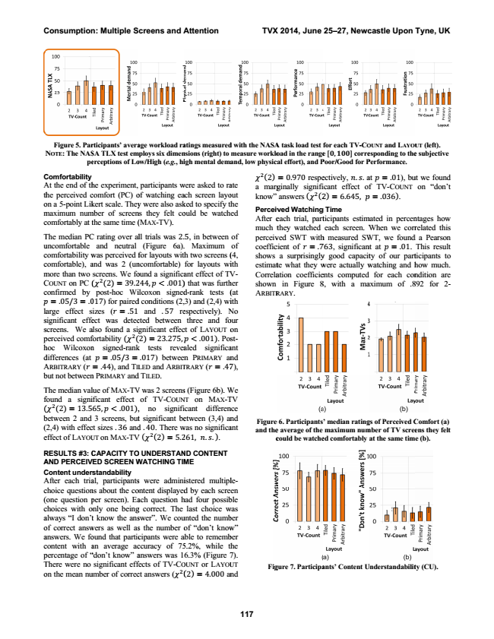

**N**

C A th o m c

T u c c m C c

la s s p h d A b

T f ( b ( e

R A C A c ( c a o a c p T o

**Consumption: Multiple Screens and Attention TVX 2014, June 25–27, Newcastle Upon Tyne, UK**

**Figure 5. Par N**

**OTE**

**: The NAS pe**

Comfortability At the end of th he perceived c on a 5-point Lik maximum num comfortably at t

The median PC uncomfortable comfortability w comfortable), a more than two COUNT on PC ( confirmed by

= .05/3 = .0 arge effect s significant effe screens. We a perceived comf hoc Wilcoxon differences (at ARBITRARY ( but not between

The median val found a signi ( (2) = 13.5 between 2 and (2,4) with effec effect of LAYOU

RESULTS #3: C AND PERCEIV Content under After each tria choice question (one question p choices with o always “I don’t of correct answ answers. We fo content with a percentage of “ There were no on the mean nu

**117**

**rticipants’ avera SA TLX test em erceptions of Lo**

he experiment, comfort (PC) o kert scale. They mber of screen the same time (

C rating over al

and neutral was perceived f and was 2 (un screens. We fo ( (2) = 39.2 post-hoc Wi 017) for paired izes ( = .51 ect was detec also found a si fortability ( ( n signed-rank

= .05/3 = = .44), and TIL n PRIMARY and

lue of MAX-TV ificant effect

65, < .001), 3 screens, but ct sizes .36 and UT on MAX-TV

**CAPACITY TO VED SCREEN W**

rstandability al, participants ns about the co per screen). Ea only one being t know the ans wers as well as ound that partic an average ac “don’t know” a significant eff umber of correc

**age workload ra mploys six dimen ow/High (e.g., hi**

participants w of watching ea y were also ask ns they felt co

(M

AX

-TV).

ll trials was 2. (Figure 6a). for layouts with ncomfortable) ound a significa 244, < .001) ilcoxon signed d conditions (2, and .57 re cted between

gnificant effec (2) = 23.275, k tests revea .017) between LED and ARBIT d TILED.

V was 2 screens of TV-COUN , no signifi t significant be d .40. There w V ( (2) = 5.2

**O UNDERSTAN**

**WATCHING TIM**

s were admini ontent displayed ach question h g correct. The swer”. We cou s the number o cipants were a ccuracy of 75 answers was 1 fects of TV-CO ct answers ( (

**atings measured nsions (right) to**

**igh mental dema**

were asked to ra ach screen layo ked to specify th ould be watch

5, in between Maximum h two screens ( for layouts wi ant effect of TV ) that was furth d-rank tests ( 3) and (2,4) wi espectively). N three and fo ct of L

AYOUT

o < .001). Pos aled significa n PRIMARY an TRARY ( = .47

s (Figure 6b). W NT on MAX-T cant differen etween (3,4) an was no significa 261, . .).

**ND CONTENT**

**ME**

istered multipl d by each scre had four possib last choice w unted the numb

of “don’t know able to rememb 5.2%, while th 6.3% (Figure 7 OUNT or LAYOU (2) = 4.000 an

**d with the NASA measure worklo and, low physic**

ate out he ed

of of (4, ith V- her (at ith No our on st- ant nd 7),

We TV nce nd ant

le- en ble was ber w” ber he 7). UT nd

(2) a marg know”

Perceiv After e much t perceiv coeffic shows estimat Correla shown ARBITR

**Figure and the c**

**Fig**

**A task load test**

**oad in the range cal effort), and P**

= 0.970 respe ginally signifi

answers ( (2

ved Watching each trial, part they watched ved SWT with cient of = .7 a surprisingly te what they w ation coefficie in Figure 8 RARY.

**e 6. Participants e average of the could be watche**

**gure 7. Participa**

**for each TV-C**

**O e , corre Poor/Good for P**

ectively, . . a icant effect of 2) = 6.645,

**g Time**

ticipants estim

each screen. W h measured SW 763, significan y good capacit were actually w ents computed 8, with a ma

**’ median rating maximum num ed comfortably**

**ants’ Content U**

**and OUNT**

**L**

**AYOU esponding to the Performance.**

at = .01), bu

f TV-C

OUNT = .036).

mated in percen When we corr WT, we found nt at = .01.

ty of our part watching and h for each con aximum of .8

**gs of Perceived C mber of TV scree at the same tim**

**Understandabilit**

**(left). UT e subjective**

ut we found on “don’t

ntages how related this d a Pearson This result ticipants to how much. ndition are 892 for 2-

**Comfort (a) ens they felt e (b).**

**ty (CU).**

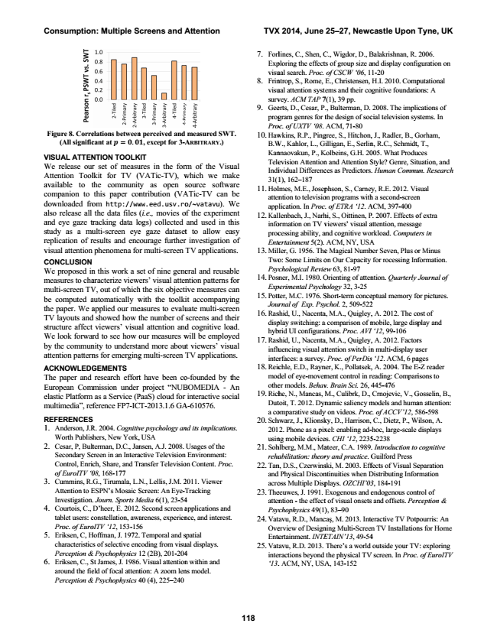

**Consumption: Multiple Screens and Attention TVX 2014, June 25–27, Newcastle Upon Tyne, UK**

**Figure 8. Corre (All signific**

V VISUAL ATTEN W We release our A Attention Tool a available to t c companion to d downloaded fro a also release all a and eye gaze tr s study as a mu r replication of r v visual attention C CONCLUSION W We proposed in m measures to cha m multi-screen TV b be computed a th

he paper. We a T TV layouts and s structure affect W We look forwar b by the commun a attention pattern

A ACKNOWLEDG T The paper and E European Com e elastic Platform m multimedia”, ref

R REFERENCES 1 1. Anderson, J.R Worth Publish 2 2. Cesar, P, Bult Secondary Sc Control, Enric of EuroITV ‘0 3 3. Cummins, R.

Attention to E Investigation. 4 4. Courtois, C.,

tablet users: c Proc. of Euro 5 5. Eriksen, C, H characteristic Perception & 6 6. Eriksen, C., S around the fie Perception &

**118**

**elations between cant at = .**

NTION TOOLK r set of measu lkit for TV (V the communit

this paper con om http://ww the data files racking data lo ulti-screen eye results and enc phenomena fo

n this work a s aracterize view V, out of which automatically w applied our me d showed how t viewers’ visua rd to see how o nity to understa ns for emerging

**GEMENTS**

research effort mmission under

as a Service (P ference FP7-IC

R. 2004. Cognitiv hers, New York, terman, D.C., Jan creen in an Intera ch, Share, and Tr 08, 168-177

G., Tirumala, L.N ESPN’s Mosaic S . Journ. Sports M D’heer, E. 2012. constellation, awa oITV ‘12, 153-15 Hoffman, J. 1972. s of selective enc & Psychophysics

St James, J. 1986 eld of focal attent & Psychophysics 4

**n perceived and**

**, except for 3-A**

**KIT**

ures in the for

VATic-TV), w ty as open s ntribution (VA ww.eed.usv.ro (i.e., movies o ogs) collected e gaze dataset courage further r multi-screen

set of nine gene ers’ visual atten h the six objecti with the toolki easures to evalu the number of al attention and our measures w and more abou g multi-screen T

t have been co project “NUB PaaS) cloud for CT-2013.1.6 GA

ve psychology an , USA nsen, A.J. 2008. active Television ransfer Televisio

N., Lellis, J.M. 2 Screen: An Eye-T Media 6(1), 23-54 . Second screen a areness, experien 6 . Temporal and s coding from visu 12 (2B), 201-204 . Visual attention tion: A zoom len 40 (4), 225–240

**measured SWT A**

**RBITRARY**

**.)**

rm of the Visu which we ma source softwa ATic-TV can b o/~vatavu). W of the experime and used in th t to allow ea r investigation

TV application

eral and reusab ntion patterns f ive measures c it accompanyin uate multi-scre screens and the d cognitive loa will be employ ut viewers’ visu TV application

o-founded by t BOMEDIA - A interactive soc A-610576.

*nd its implication*

Usages of the Environment: on Content. Proc.

2011. Viewer

Tracking 4 applications and nce, and interest.

spatial ual displays. 4 n within and ns model.

**T.**

ual ke are be We ent his asy of ns.

ble for an ng en eir ad. ed ual ns.

the An ial

*ns.*

*.*

7. Forl Exp visu 8. Frin visu surv 9. Gee prog Pro 10. Haw B.W Kan Tele Indi 31(1 11. Hol

atten app 12. Kal info proc Ente 13. Mil

Two Psy 14. Posn

Exp 15. Pott

Jour 16. Ras disp hyb 17. Ras

influ inte 18. Reic mod othe 19. Rich

Dut a co 20. Sch 201 usin 21. Soh

reha 22. Tan and acro 23. The

atten Psy 24. Vat

Ove Ente 25. Vat inte ‘13.

lines, C., Shen, C

C., Wigdor, D., B

2006. ploring the effect

ts of group size a

guration on ual search. Proc.

of CSCW ‘06, 1 ntrop, S., Rome,

E., Christensen,

putational ual attention syst

tems and their co

ons: A vey. ACM TAP 7

7(1), 39 pp. erts, D., Cesar, P

., Bulterman, D.

ications of gram genres for t

the design of soc

*stems. In oc. of UXTV ‘08.*

ACM, 71-80 wkins, R.P., Ping

gree, S., Hitchon,

Gorham, W., Kahlor, L., G

Gilligan, E., Serlin

, T., nnaovakun, P., K

Kolbeins, G.H. 20

uces evision Attention

n and Attention S

tuation, and ividual Differenc

ces as Predictors

un. Research 1), 162–187 lmes, M.E., Josep

phson, S., Carney

sual ntion to televisio

on programs with

n lication. In Proc

c. of ETRA ‘12. A llenbach, J., Narh

hi, S., Oittinen, P

of extra ormation on TV v

viewers’ visual a

ge cessing ability, a

and cognitive wor

*ers in ertainment 5(2).*

ACM, NY, USA ller, G. 1956. The

e Magical Numb

or Minus o: Some Limits o

on Our Capacity

*formation. ychological Revie*

ew 63, 81-97 ner, M.I. 1980. O

Orienting of atten

*Journal of perimental Psych*

hology 32, 3-25 ter, M.C. 1976. S

Short-term conce

*or pictures. rnal of Exp. Psy*

ychol. 2, 509-522 shid, U., Nacenta

a, M.A., Quigley,

ost of play switching: a

a comparison of m

play and brid UI configura

ations. Proc. AVI shid, U., Nacenta

a, M.A., Quigley,

rs uencing visual at

ttention switch in

user erfaces: a survey.

*. Proc. of PerDis*

ages chle, E.D., Rayn

ner, K., Pollatsek,

E-Z reader del of eye-movem

ment control in r

isons to er models. Behav

v. Brain Sci. 26, 4 he, N., Mancas, M

M., Culibrk, D.,

Gosselin, B., toit, T. 2012. Dyn

namic saliency m

an attention: omparative study

y on videos. Proc

86-598 hwarz, J., Klionsk

ky, D., Harrison,

Wilson, A. 2. Phone as a pix

xel: enabling ad-

displays ng mobile device

es. CHI ‘12, 2235 hlberg, M.M., Ma

ateer, C.A. 1989.

*cognitive abilitation: theor*

ry and practice. G n, D.S., Czerwins

ski, M. 2003. Eff

eparation d Physical Discon

ntinuities when D

rmation oss Multiple Disp

plays. OZCHI’03 eeuwes, J. 1991.

Exogenous and e

trol of ntion - the effect

t of visual onsets

*rception & ychophysics 49(1)*

), 83–90 tavu, R.D., Manc

caș, M. 2013. Inte

pourris: An erview of Design

ning Multi-Screen

ns for Home ertainment. INTE

ETAIN’13, 49-54 tavu, R.D. 2013.

There’s a world

V: exploring eractions beyond

the physical TV

of EuroITV . ACM, NY, USA

A, 143-152

Balakrishnan, R. and display confi

1-20 H.I. 2010. Comp ognitive foundatio

2008. The impli cial television sys

, J., Radler, B., G n, R.C., Schmidt, 005. What Produ Style? Genre, Sit . Human Commu

y, R.E. 2012. Vi h a second-screen ACM, 397-400 P. 2007. Effects o attention, messag rkload. Compute A ber Seven, Plus o for rocessing Inf

*ntion. Quarterly*

eptual memory fo 2 , A. 2012. The co mobile, large disp I ‘12, 99-106

, A. 2012. Factor n multi-display u s ‘12. ACM, 6 pa , A. 2004. The E reading: Compari

445-476 Crnojevic, V., G models and huma c. of ACCV’12, 5 C., Dietz, P., W -hoc, large-scale 5-2238 . Introduction to Guilford Press fects of Visual Se Distributing Infor

3, 184-191 endogenous cont s and offsets. Per

eractive TV Potp n TV Installation 4

outside your TV V screen. In Proc.